B. In-Depth Explanation & Analysis
1. State Functions vs. Path Functions
- State Function: A property whose value depends only on the initial and final state, not on the path taken. Imagine climbing a mountain: your altitude change is the same whether you hike the trail or fly in a helicopter.
- Examples: Internal Energy ( $U$ ), Enthalpy ( $H$ ), Entropy ( $S$ ), Gibbs Energy ( $G$ ), Temperature ( $T$ ).
- Path Function: Depends on how you get there.
- Examples: Work ( $w$ ) and Heat ( $q$ ).
2. The Sign Convention (Crucial for Numericals) Students lose marks here more than anywhere else.
- Heat $(q)$ : Absorbed by system $=$ Positive $(+q)$. Released by system $=$ Negative $(-q)$.
- Work ( $w$ ): Done on the system (compression) = Positive ( $+w$ ). Done by the system (expansion) = Negative ( $-w$ ).
- Tip: In Chemistry, we focus on the system's gain. If energy comes in (as work or heat), it's positive.
Mentor insight: Pay close attention to the sign convention and to words such as “by” or “on” in the question when referring to work done.
3. Enthalpy ( $ΔH$ ) vs. Internal Energy ( $ΔU$ )
- $ΔU$ is heat exchange at constant volume (bomb calorimeter).
- $ΔH$ is heat exchange at constant pressure (open beaker).
- Relationship: $ΔH=ΔU+Δn_{g}RT$, where $Δn_{g}$ is the change in moles of gaseous products minus reactants.
- Misconception: Students often count moles of solids or liquids in $Δn_{g}$. Don't! Only gases count.
BOMB CALORIMETER
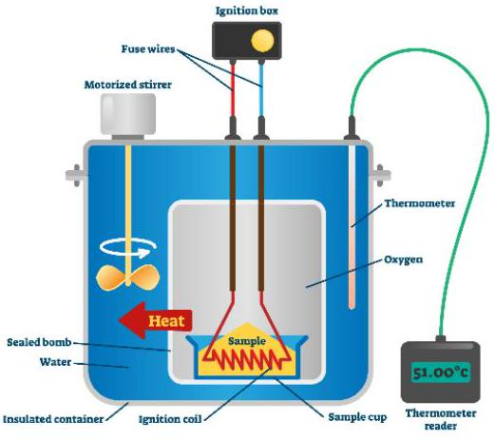
4. Spontaneity and Gibbs Energy Just because a reaction is exothermic ( $ΔH<0$ ) doesn't mean it's spontaneous (e.g., water freezing is exothermic but only spontaneous below $0^{∘}C$ ).
- $ΔG=ΔH-TΔS$
- If $ΔH$ is negative (favorable) and $ΔS$ is positive (favorable), $ΔG$ is always negative (Spontaneous).
- If $ΔH$ is positive (unfavorable) and $ΔS$ is negative (unfavorable), $ΔG$ is always positive (Non-spontaneous).
- If they oppose each other, Temperature decides the winner.

